**Operating Systems and Concurrency**

**Student Name:** Raphael Salaja

**AIT Student number:** A00269349

**Assignment:** Assignment 4

**Date of Submission:** 10/11/2021

**FORM A1**

# STUDENT PLAGIARISM DISCLAIMER FORM



## PLAGIARISM DISCLAIMER

STUDENT NAME: Raphael Salaja

STUDENT NUMBER: A00269349

PROGRAMME: BSc (Hons) in Software Design with Virtual Reality and Gaming

YEAR: 3

MODULE: Operating Systems and Concurrency

LECTURER: Thiago Braga Rodrigues

ASSIGNMENT TITLE: Lab 4 Assignment

DUE DATE: 17 November2021

DATE SUBMITTED: 10 November 2021

ADDITIONAL INFORMATION:

I understand that plagiarism is a serious academic offence, and that AIT deals with it according to the AIT Policy on Plagiarism.

I have read and understand the AIT Policy on Plagiarism and I agree to the requirements set out therein in relation to plagiarism and referencing. I confirm that I have referenced and acknowledged properly all sources used in preparation of this assignment. I understand that if I plagiarise, or if I assist others in doing so, that I will be subject to investigation as outlined in the AIT Policy on Plagiarism.

I understand and agree that plagiarism detection software may be used on my assignment. I declare that, except where appropriately referenced, this assignment is entirely my own work based on my personal study/or research. I further declare that I have not engaged the services of another to either assist in, or complete this assignment.

## Signed:Raphael Salaja

**Dated: 10 November 2021**

# Contents

STUDENT PLAGIARISM DISCLAIMER FORM 2

PLAGIARISM DISCLAIMER 2

Signed:Raphael Salaja 2

Contents 3

Setup 4

Main 4

Consumer 4

Producer 4

Output 4

Question 1 4

Main 4

Consumer 4

Producer 5

Output 6

Question 2 7

Output 7

Question 3 8

Producer 8

Output 8

Question 4 9

Main 9

Consumer 9

Producer 9

Output 9

Question 5 10

Main 10

Consumer 10

Producer 10

Output 10

# Setup

Create a ArrayBlockingQueue size 10 Create a Producer thread. Create a Consumer thread. Start both threads in Main.java and see the output.

## Main

package ie.ait.week5.blockingqueue;  
import java.util.concurrent.ArrayBlockingQueue;  
import java.util.concurrent.*BlockingQueue*;  
public class Main {  
 public static void main(String[] args) {  
 *BlockingQueue*<Integer> buffer = new ArrayBlockingQueue<Integer>(10);  
 Thread p = new Producer(buffer);  
 p.start();  
 Thread c = new Consumer(buffer);  
 c.start();  
 }  
}

## Consumer

package ie.ait.week5.blockingqueue;  
import java.util.concurrent.*BlockingQueue*;  
public class Consumer extends Thread implements *Runnable* {  
 private final *BlockingQueue*<Integer> queue;  
 @Override  
 public void run() {  
 while (true) {  
 try {  
 process(1);  
 queue.take();  
 } catch (InterruptedException e) {  
 e.printStackTrace();  
 }  
 }  
 }  
 private void process(Integer take) throws InterruptedException {  
 System.*out*.println("[Consumer] Takes : " + take);  
 Thread.*sleep*(500);  
 }  
 public Consumer(*BlockingQueue*<Integer> queue) {  
 this.queue = queue;  
 }  
}

## Producer

package ie.ait.week5.blockingqueue;  
import java.util.concurrent.*BlockingQueue*;  
public class Producer extends Thread implements *Runnable* {  
 private final *BlockingQueue*<Integer> queue;  
 @Override  
 public void run() {  
 try {  
 process();  
 } catch (InterruptedException e) {  
 Thread.*currentThread*().interrupt();  
 }  
 }  
 private void process() throws InterruptedException {  
 try {  
 for (int i = 0; i < 20; i++) {  
 System.*out*.println("[Producer] Puts : " + i);  
 queue.put(i * i);  
 try {  
 *sleep*((int) (Math.*random*() * 100));   
 } catch (InterruptedException e) {  
 }  
 }  
 System.*out*.println("Producer DONE! ");  
 } catch (Exception e) {  
 e.printStackTrace();  
 }  
 }  
 public Producer(*BlockingQueue*<Integer> queue) {  
 this.queue = queue;  
 }  
}

## Output

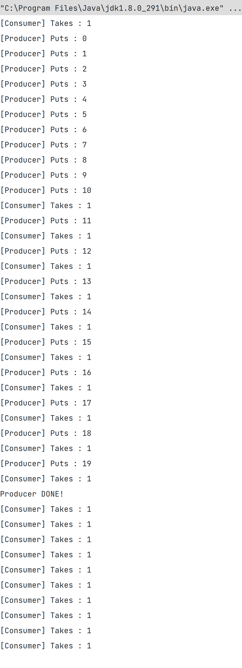

# Question 1

Run with a fast Producer and slow Consumer. What can you notice in this case?.

## Main

package ie.ait.week5.blockingqueue;  
import java.util.concurrent.ArrayBlockingQueue;  
import java.util.concurrent.*BlockingQueue*;  
public class Main {  
 public static void main(String[] args) {  
 *BlockingQueue*<Integer> buffer = new ArrayBlockingQueue<Integer>(10);  
 Thread p = new Producer(buffer);  
 p.start();  
 Thread c = new Consumer(buffer);  
 c.start();  
 }  
}

## Consumer

package ie.ait.week5.blockingqueue;  
import java.util.concurrent.*BlockingQueue*;  
public class Consumer extends Thread implements *Runnable* {  
 private final *BlockingQueue*<Integer> queue;  
 @Override  
 public void run() {  
 while (true) {  
 try {  
 process(queue.take());  
 } catch (InterruptedException e) {  
 e.printStackTrace();  
 }  
 }  
 }  
 private void process(Integer take) throws InterruptedException {  
 System.*out*.println("[Consumer] Takes : " + take);  
 Thread.*sleep*(100);  
 }  
 public Consumer(*BlockingQueue*<Integer> queue) {  
 this.queue = queue;  
 }  
}

## Producer

package ie.ait.week5.blockingqueue;  
import java.util.concurrent.*BlockingQueue*;  
public class Producer extends Thread implements *Runnable* {  
 private final *BlockingQueue*<Integer> queue;  
 @Override  
 public void run() {  
 try {  
 process();  
 } catch (InterruptedException e) {  
 Thread.*currentThread*().interrupt();  
 }  
 }  
 private void process() throws InterruptedException {  
 try {  
 for (int i = 0; i < 20; i++) {  
 System.*out*.println("[Producer] Puts : " + i);  
 queue.put(i);  
 try {  
 *sleep*((int) (Math.*random*() * 100));   
 } catch (InterruptedException e) {  
 }  
 }  
 System.*out*.println("Producer DONE! ");  
 } catch (Exception e) {  
 e.printStackTrace();  
 }  
 }  
 public Producer(*BlockingQueue*<Integer> queue) {  
 this.queue = queue;  
 }  
}

## Output

# Question 2

Run with slow Producer and fast Consumer. Now make the Consumer sleep for4 seconds between iterations. What is the difference?

## Output

# Question 3

Include a parameter in the constructor for the Producer that specifies the startinteger and now loops from this value.

## Producer

package ie.ait.week5.blockingqueue;  
import java.util.concurrent.*BlockingQueue*;  
public class Producer extends Thread implements *Runnable* {  
 private final *BlockingQueue*<Integer> queue;  
 private final int start;  
 @Override  
 public void run() {  
 try {  
 process();  
 } catch (InterruptedException e) {  
 Thread.*currentThread*().interrupt();  
 }  
 }  
 private void process() throws InterruptedException {  
 try {  
 for (int i = start; i < 20 + start; i++) {  
 System.*out*.println("[Producer] Puts : " + i);  
 queue.put(i * i);  
 try {  
 *sleep*((int) (Math.*random*() * 1000));  
 } catch (InterruptedException e) {  
 }  
 }  
 System.*out*.println("Producer DONE! ");  
 } catch (Exception e) {  
 e.printStackTrace();  
 }  
 }  
 public Producer(*BlockingQueue*<Integer> queue, int start) {  
 this.queue = queue;  
 this.start = start;  
 }  
}

## Output

# Question 4

Start a few Producers and only one Consumer. What happens in this case?

## Main

package ie.ait.week5.blockingqueue;  
import java.util.concurrent.ArrayBlockingQueue;  
import java.util.concurrent.*BlockingQueue*;  
public class Main {  
 public static void main(String[] args) {  
 *BlockingQueue*<Integer> buffer = new ArrayBlockingQueue<Integer>(10);  
 Thread p_1 = new Producer(buffer, 5);  
 Thread p_2 = new Producer(buffer, 1);  
 Thread p_3 = new Producer(buffer, 3);  
 Thread p_4 = new Producer(buffer, 4);  
 p_1.start();  
 p_2.start();  
 p_3.start();  
 p_4.start();  
 Thread c = new Consumer(buffer);  
 c.start();  
 }  
}

## Output

# Question 5

Use a method poll instead of the take method. Print the output from that method. What happens is the queue is empty?

## Consumer

package ie.ait.week5.blockingqueue;  
import java.util.concurrent.*BlockingQueue*;  
public class Consumer extends Thread implements *Runnable* {  
 private final *BlockingQueue*<Integer> queue;  
 @Override  
 public void run() {  
 try {  
 Thread.*sleep*(1000);  
 } catch (InterruptedException e) {  
 e.printStackTrace();  
 }  
 while (true) {  
 try {  
 Integer x = queue.poll();  
 if (x == null) {  
 System.*out*.println(" CONSUMER DONE ");  
 break;  
 }  
 process(x);  
 } catch (InterruptedException e) {  
 e.printStackTrace();  
 }  
 }  
 }  
 private void process(Integer take) throws InterruptedException {  
 System.*out*.println("[Consumer] Takes : " + take);  
 Thread.*sleep*(500);  
 }  
 public Consumer(*BlockingQueue*<Integer> queue) {  
 this.queue = queue;  
 }  
}

## Output

